**Assignment**

1. Need to use Prometheus Time Series Database and plot your own performance graphs using Grafana Dashboard by creating different movement graphs as per the attendance marking parameter.

To Setup Grafana run below given command:

root@yogendra:/home# **docker run -itd --name grafana -p 3000:3000 docker.io/grafana/grafana**

root@yogendra:/home# **docker ps**

CONTAINER ID IMAGE COMMAND CREATED STATUS PORTS NAMES

b806cb91ab7a grafana/grafana "/run.sh" 24 seconds ago Up 23 seconds 0.0.0.0:3000->3000/tcp, :::3000->3000/tcp grafana

root@yogendra:/home# **docker exec -it grafana bash**

bash-5.1$ ls

LICENSE NOTICE.md README.md VERSION bin conf plugins-bundled public scripts

bash-5.1$ **grafana-cli plugins install grafana-googlesheets-datasource**

✔ Downloaded and extracted grafana-googlesheets-datasource v1.1.5 zip successfully to /var/lib/grafana/plugins/grafana-googlesheets-datasource

Please restart Grafana after installing plugins. Refer to Grafana documentation for instructions if necessary.

bash-5.1$

**OR**

Run below given command:

root@yogendra:/home# **docker run -itd --name grafana -p 3000:3000 -e "GF_INSTALL_PLUGINS=grafana-googlesheets-datasource" docker.io/grafana/grafana**

Now Open the browser and write below given to open the grafana.

**localhost:3000/**

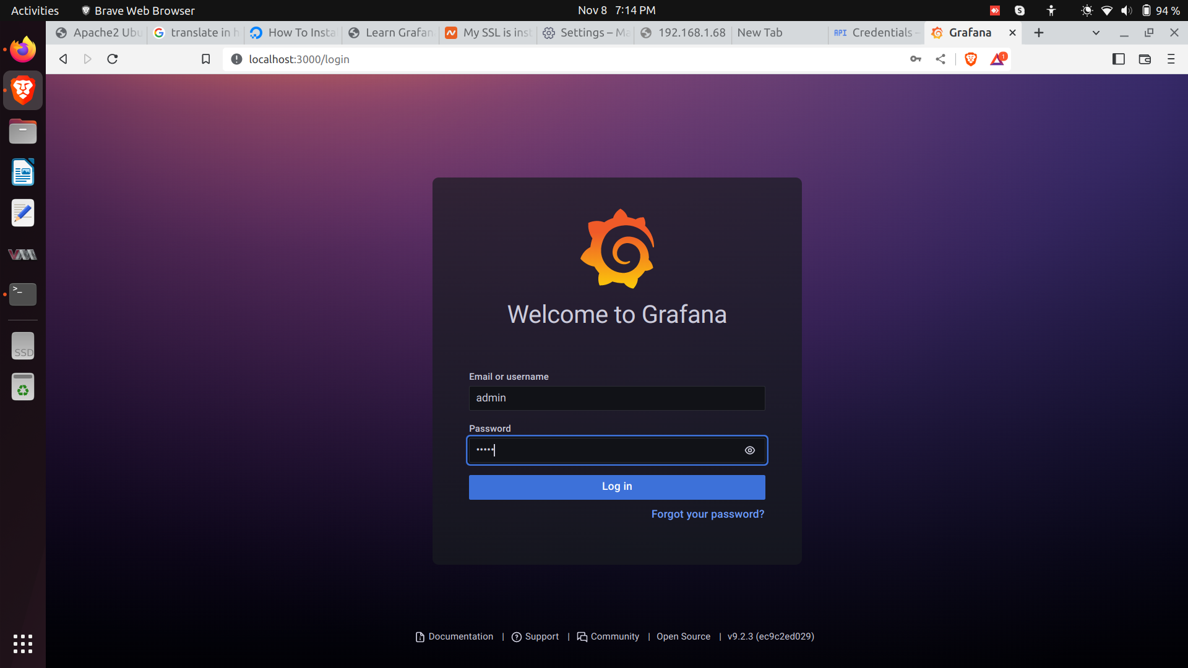

**Now Create google API (google sheet API) and enable google sheets API:**

To create the API key you need to google cloud .google.com. To create the API key , open your browser type **“console.cloud.google.com/home ”.**



